Steps for creating JaCoCo report

1. Run the JUnit tests with JaCoCo coverage (you can do this on multiple files, folders, and/or multiple folders)

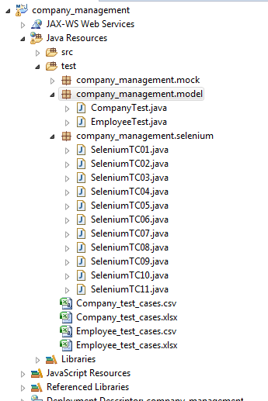

**Here is the folder for the non-Selenium JUnit tests. We can execute all the tests from this folder in the following steps.**

1. Right click on the **folder**, select Coverage As -> JUnit test. All tests will be run using JaCoCo.
2. Now look at the JaCoCo Coverage tab in Eclipse (see below)

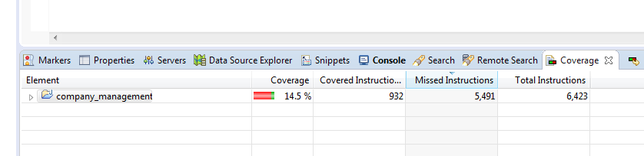

1. In the Coverage tab **right click** on the Project name
2. Select Export Session...

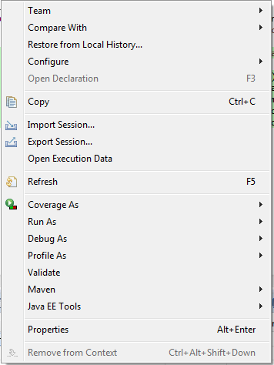

1. In the popup (see below) make sure that
   1. **HTML Report** is selected in Format
   2. that Destination folder is correct
   3. On the Popup select the **Browse...** button
   4. Create a new folder named CoverageSessions as shown below

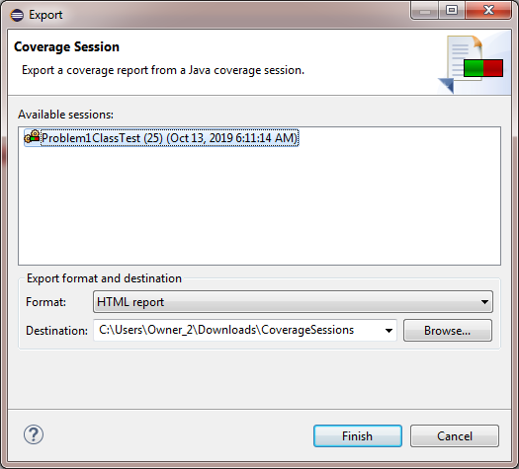

1. Click **Finish**
2. Zip the CoverageSessions folder for your A04 delivery
3. During your presentation you can open the individual results by
   1. navigating to the src folder (in the project folder)
   2. opening the desired folder
   3. double click on the Class.java.html file - this is the file we saw in CSE 5321